Student No: 219296087 | Group No: 2
Student Name (as per record): Gulbaz Khan

In the following report, we analyse Claudia care with three important factors to have a clear picture of the current situation of the business and how it can be improved to meet the demand and competition in the times ahead. Claudia care has been successful in providing their services to the clients with great satisfaction but to expand the business there are certain factors which have to be make a step forward in expansion of business.

Firstly, Mind mapping is used to understand the complex structure of the organisation and the factors on which this business depends. Mind mapping is an effective visualisation technique to make notes, look into your thoughts, planning and organising the thoughts. This technique makes the complex problem easy to understand.

Secondly, SWOT analysis has been done to recognise the strengths to address the threats which can cause problems to the business model and opportunities has been pointed out to overcome the weakness in the current business. By using these techniques, we have suggested some strategies on how to move forward with the future business plans and recommendations have been made accordingly. We have identified several strengths, weakness, opportunities and threats but according to our analysis the root cause of the weakness was technology as the company is lacking technology so we suggest moving forward with hand in hand with technological AI company which will play an important part in upscaling the Claudia care company.

Finally, Stakeholder analysis is used to highlight the most important factors while implementing the future business models using the strategies suggested. It analyses the influence and impact of the key decision makers and the stakeholders with the risks associated with it in Table 1. We have plotted the stakeholders with respect to their influence and impact to view the important results visually. We suggest taking this visual representation into account while making the future decision as the most important stakeholders according to our analysis are the management team of Claudia care and the third-party IT company which will be providing their services to Claudia care to move forward with respect to technology to tackle the needs and demand of the business model.

Your Mind Map:

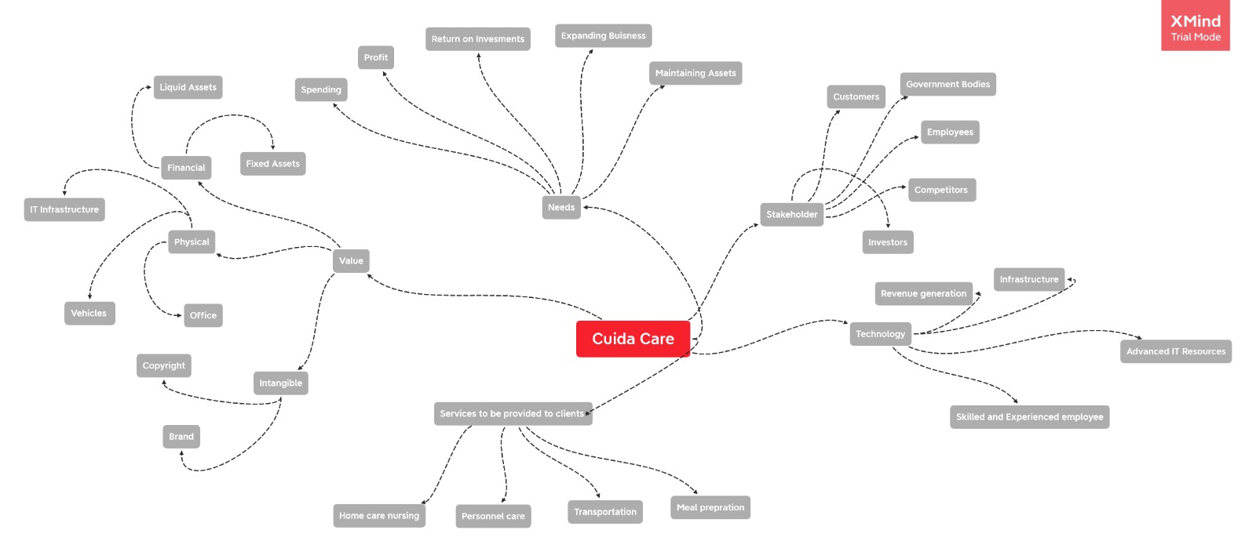

Annotation, rationale, and assumptions

SWOT Table
Strengths  S1. Professional well-trained Staff  S2. Versatile Services  S3. Location with high demand and high population.  S4. Trustable as it is government subsidised.  S5. Work-life balance for employees | Opportunities  O1. The Demand is Increasing due to covid 19 can do more business.  O2. Open Online AI based training centres.  O3. Collaborate with IT companies to use AI to improve the system.  O4. Global opportunities with good training.  O5. The investors are ready to invest in healthcare due to high demand.
Weaknesses  W1. Management system is weak to monitor the quality.  W2. Behind in Technology  W3. No trainers to train new people  W4. Less staff to cater the needs  W5. New staff with less experience | Threats  T1. Due to Covid-19 many people do not want to work in aged-care services.  T2. Other companies can hire the trained staff.  T3. Government can pull back their grants.  T4. Competition from other companies with lower price.  T5. Franchises can reduce the quality of services.
Annotations, assumptions, and references

Strategy development and Recommendations

 | External O2- Open online AI based Training centres
Internal:  W2- Behind in Technology | Strategy 1: W2O2: As the company is behind in technology, they can run an online compulsory training before starting the job and to train new people to expand the business. By using this strategy, they can overcome their weakness in technology as the staff will be learning the new technology and the staff will be already trained to expand the busniness.
 | External O3- Collaborate with IT companies to use AI to improve the system
Internal  W1- Management System is weak to monitor the quality  e | Strategy 2: W1O3: The management system can be improved using the AI technology by collaborating with the IT companies which are willing to introduce and test their new technology. The management system is out-dated, and the IT companies are willing to test their systems in the markets. The management system is the backbone of any business and if this strategy is implemented, we can over-come weakness in the company and have access to more opportunities. By using this, we can also avail O5- investor will invest in technology and heathcare.
Recommendation, justification, actions and how to measure success (reference back to one or more of your strategies)
i.e., explain briefly which strategy or their combination you recommend adopting
We recommend to go ahead with the Strategy two. This is addressing more problems as compared to the other strategy. As the company is moving forward with the AI, it will be able to provide better services to the clients by using the predictive models of the market trends. The company already has a brand name is the market so adapting to the AI technology will not only make its management system centralized but also be able to pull out government grants and investors’ money into the business model. It will be easy for the company to manage the business on a large scale as it will be able to franchise out the company name with maintaining the same standards of service. If we test the new technology on the small scale model of the company, seeing the results and benchmarking it with the large scale model will be our measure of success.

Table 1

 |  | Importance | Influence | Assumptions | Risk
1 | Board members | 10 | 8 | Bad decisions taken by the Board members | Negative company growth
2 | Management team | 10 | 10 | Not able to manage the team properly. | The team will have no direction to work.
3 | Patients | 1 | 0 | They will be using the AI technology | They fail to understand the new technology
4 | Staff | 2 | 0 | It might be difficult for the staff to understand the new software. | The company will have to invest more in training of the staff.
5 | Franchisees | 6 | 2 | Poor performance by the franchisee. | The company name will be affected.
6 | Investors | 8 | 7 | They will be keen to invest in new technologies. | If there is no investment, the company can face losses.
7 | IT company | 10 | 9 | The company is capable of implementing new software. | Claudia care is dependent on this company.
8 | Software Tech providers | 5 | 5 | The software is robust and user friendly. | The IT company is responsible for the correct usage of softwares.
9 | Hardware providers | 5 | 5 | The hardware of the system is up to date to meet the increasing demand. | The whole system can fail if the hardware is not correct.
10 | Operational manager | 7 | 7 | He is able to manage the operation as the team is dependent of him. | The whole team will have no direction if he fails.
11 | Legislative bodies | 3 | 8 | Change in Governing policies and taxes | The company have to change their policies according to the government.
12 | Developers | 5 | 5 | The developers are meeting the deadlines. | The software would not be developed.
13 | Technical managers | 4 | 3 | The technical managers are able to debug the errors. | The software can crash anytime due to any error by the team.

